Tectonic Processes

References-
1. Chasmer Pg. 157-162, 163-169, 183-191
2. Smythe Pg. 80-87, 99-108, 146-149

Rock Types-using your text book make point form notes on the
1. a. Three types of Sedimentary rock-give two examples of each
b. What type of rock do sand grains become?, Grains of clay?
2. Metamorphic rock-describe the process
b. What type of metamorphic rock is formed by the transformation of
sandstone, limestone, shale
3. Igneous rock-describe the process
b. Give two examples of Intrusive and Extrusive Igneous rock
4. Using the diagram below give the names of the numbered features.
Chasmer-Pg. 183 Smythe Pg. 108

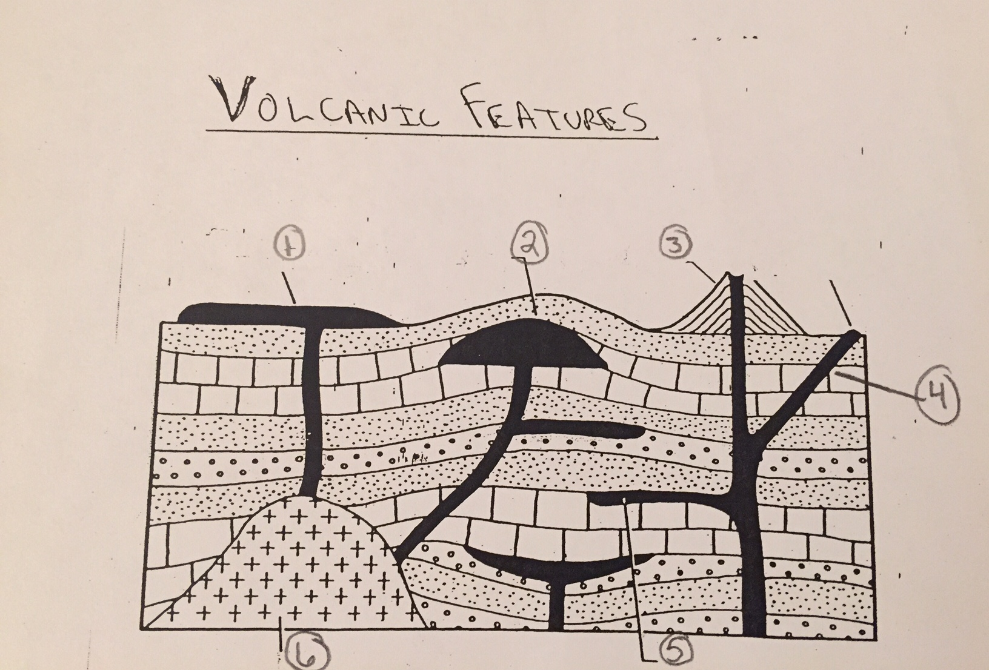

5. Using a basic chart or point form notes show understanding of the following igneous rocks. Describe the following for each-
-how they are formed, appearance(light or dark, visible or tiny crystals),
acidity, intrusive or extrusive
Granite, Andesite, Basalt, Obsidian, Pumice
-use the chart in Smythe
6. With the aid of a diagram describe the formation of
a. geysers b. hot springs
Identify at least two place in North America where geothermal activity takes place.

